Renju lesson on April 5, 2001

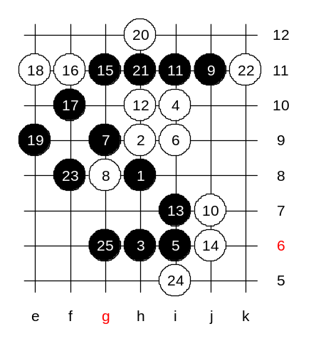
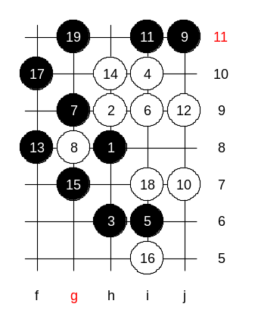
Hello all! Welcome to Online Renju Class. Today we will continue with d11 opening. Today we will use correct 8th move. Black is now forced to block it from upper side. Before learning about the traditional 10th move, we should review several gambling 10th moves that should give black win. That way you are prepared against gambling players who might want to surprise you with those 10th moves. First we check 10-j7. All those gambling 10th moves give black win. Black win is really difficult. The book says 11-i11. Lets see why. The reason is, since black had no VCT, the development move with control style had to be made. Black has many open lines now. White must either block passively, or actively. Lets try 12-h10 first, as a passive style. How to win? I think it is important that black reaches first to h12 point. So, we have no other choice but i7. And now black has enough time to reach h12 first. White will try to bother black with active f11. Black begins winning attack with e9. White 24-i5 gives white VCF threat! What should black do now? Where can black play? G6, indeed. This is the only move that cuts the white VCF and keeps its own attack. The further moves are easy, black wins soon. No need to try.

We try another 12th move now. The active style. White creates many lines with j9. Now there is a big chaos on the board. Both black and white have lots of active lines that control each other. It is not easy to find the winning path in such situations. F8 is the beginning. OK, we first block from h10. Black wins easily. We should use another 14th move.
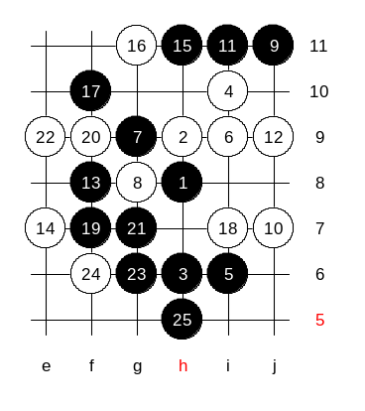

Here, black must play very carefully. Please note the sequence of moves.
White didn’t use a four to f7 and therefore black wins easily here.
Move 21-g7 is the win move. If white blocks below the black goes g6 and then VCF in upper side.

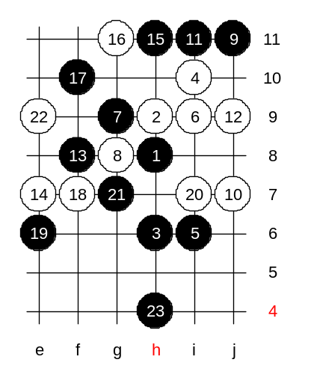

Now, white played f7 first.
The h4 is the final win move.

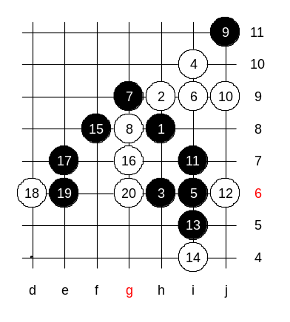

Time to learn about another 10th move.
This 10-j9 is not so strong. Black has VCT win here.
Just to make it more interesting, I use another 15th move.
The 20th move is the strongest defense.
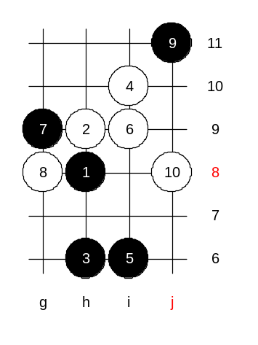
This is the medium level homework. Please find the black win.

This is the advanced level homework.
Please find the black win.

